**Borders and Boundaries**

1. Ramaiah, Ahmed and John are friends. They have decided to fence their lands.Who needs fencing wire more?

Option A)

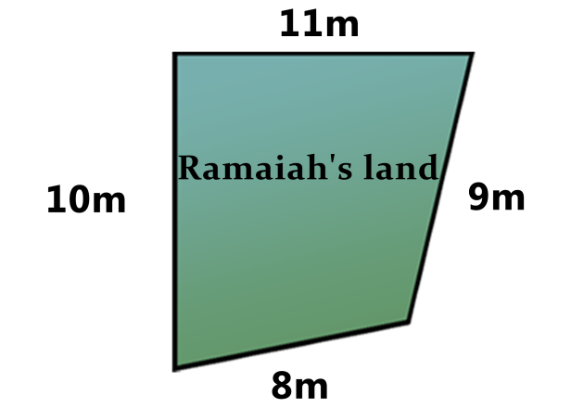

Option B)

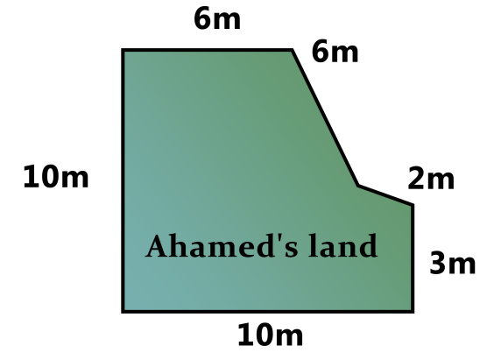

Option C)

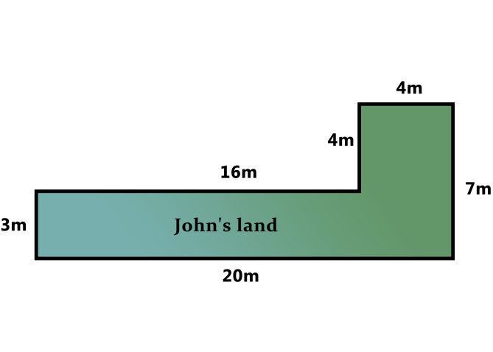

Answer: Option 3

2. The measurements of Ranga's and Rama's fields are given below. They both want to buy fencing wire. Who needs more wire?

Option A)

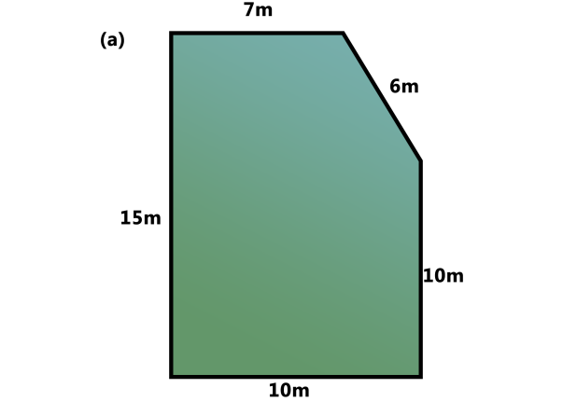

Option B)

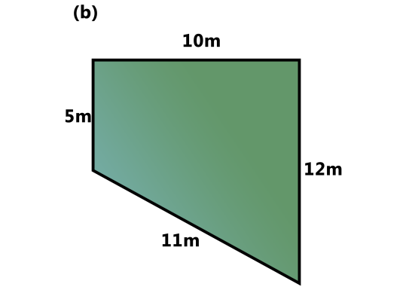

Answer: Option A

3. Which of the following closures has more perimeter.

Option A)

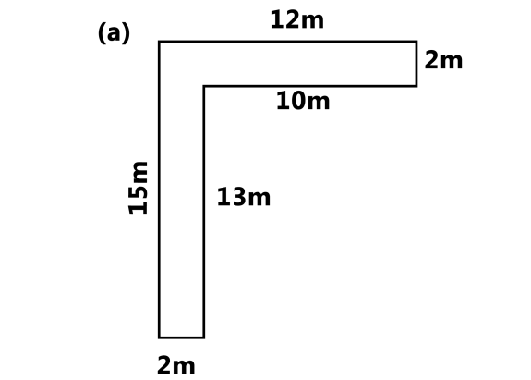

Option B)

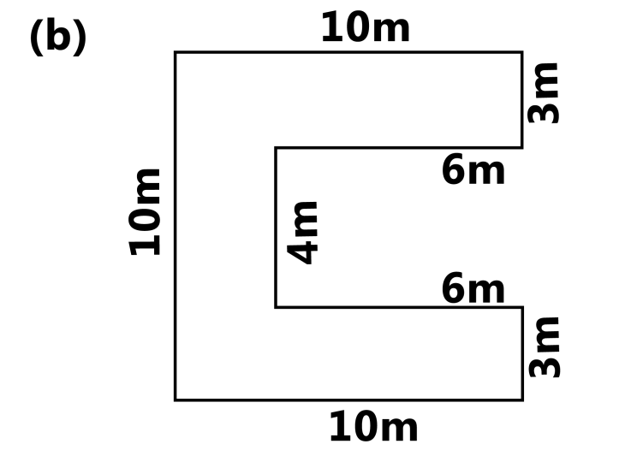

Option C)

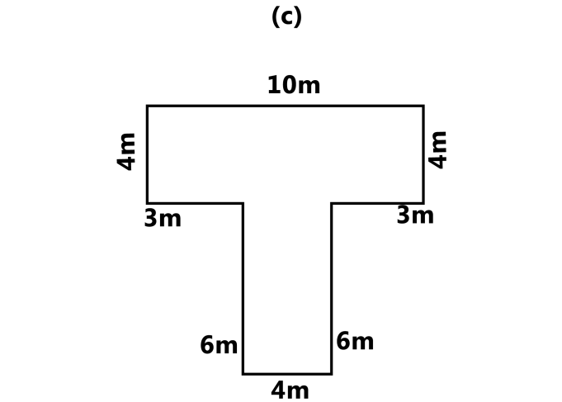

Answer: A

4. Which of the following closures have perimeter equals to 40.

Option A)



Option B)



Option C)



Answer: C

5. Which of the following closures has more perimeter.

Option A)

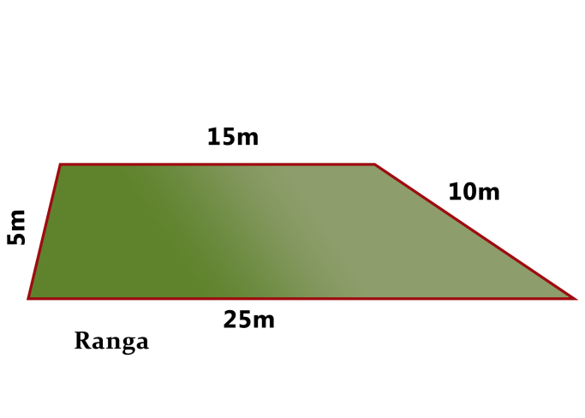

Option B)

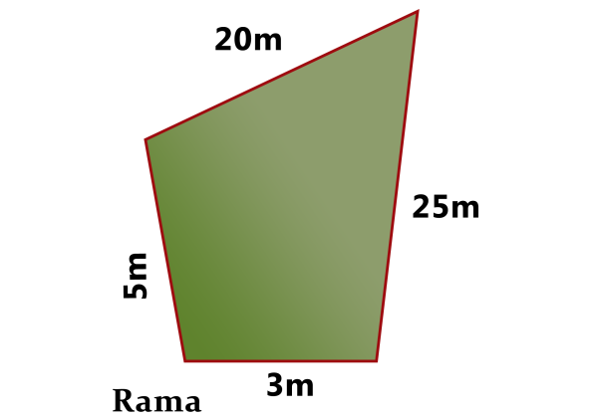

Option C)

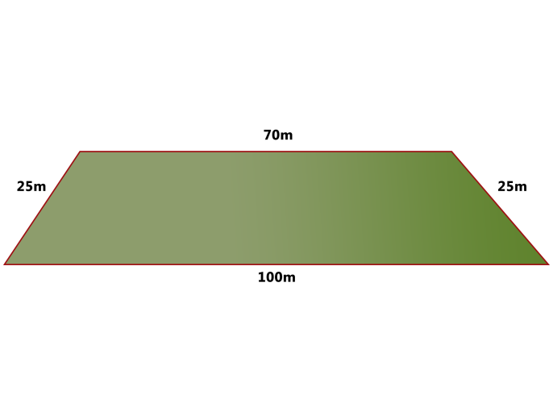

Answer: Option C